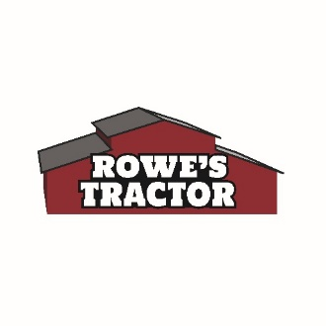
November 8, 2022
FOR IMMEDIATE RELEASE:

ADAAN’S OPERATION SAVE CHRISTMAS RETURNS TO ROWE’S TRACTOR
(East Wenatchee, WA) Local middle school student, Adaan Velazquez Operation Save Christmas has given thousands of kids’ toys who may otherwise not have toys on Christmas. Since 2016, Adaan has spreadheaded the local toy drive. Last year, he collected over 2,500 toys and hopes to surpass that number this holiday season.
Customers are asked to deliver an unwrapped toy, appropriate for kids under 18 years old to Rowe’s Tractor on the corner of Rock Island Road in East Wenatchee. Collection runs from Tuesday, November 8th to Friday, December 16th. All toys will be wrapped by Adaan and his many helpers, and then delivered to children in area before December 25th.
Adaan and his mom, Summer, coordinate with Child Protective Services (CPS), Sage, Grace House, Women’s Resource Center and other organizations to ensure the kids who may not otherwise have the opportunity to have other present this Christmas.
Ways to donate and help:
Customers can deliver cash contributions, toys, shop the Amazon wish list, or register to help wrap toys.
- Deliver the unwrap gift to Rowe’s Tractor, 300 Rock Island Road, East Wenatchee, WA
- Drop off a cash contribution at Rowe’s, ATTN: Adaan’s Operation Save Christmas
- Shop the Amazon Wishlist: https://www.amazon.com/hz/wishlist/ls/22BNQ8RYNGD8P...

If you want to sign up to help wrap the gifts, please stop by Rowe’s Tractor.
Adaan’s Operation Save Christmas is supported by Rowe’s Tractor, Holiday Muffler, Hooked on Toys and more.

For more information or learn more about the Operation Save Christmas, please email: info@jbemarketinggroup.com or stop by Rowe’s Tractor in East Wenatchee.
###

